NHB+ Selling To Women 3.0

Mindset:

Language of doubts

Change your language from

If I get this offer making $50k / month

To

When I get this offer making 50k / month

IF is a form of doubt, WHEN is an expectation

Whenever you use the word “IF” anywhere, that creates the possibility of NOT working.

If you have any type of FEAR, it will feed the if, into the NOT side.

WHEN or ONCE creates an expectation in TIME.

When you use the word WHEN or ONCE, the mind can shift to accelerating the timeline FASTER, because it goes into the HOW.

Get the mind into the HOW state.

If this, THEN this. The IF does not get the mind into the HOW state.

The HOW state is what gets the mind to look for a way to create a process and thus all change happens because of a process.

All change happens because of a process.

Once it creates the process -> all it needs is EMOTIONAL FUEL to fuel it to achieve it.

If you can’t get to the HOW / process stage of the transformation, the emotional fuel doesn’t work. It works backwards, because it will feed the other side of the IF, which is FEAR.

Emotional fuel is anything that gets your solar plexus to expand.

The way you KNOW that you have ENOUGH emotional FUEL is when you nearly start CRYING.

When your CNS is causing your body to react to your thoughts.

Crying in joy.

The language you should ALWAYS use is

WHEN
ONCE
HOW

These are the 3 most powerful words that lead you to getting your mind to find the path to your goals.

–

The self worth test

“What do you want””

If nothing comes up or you don’t know what you want, that is a subconscious communication that you are not worthy of anything.

Because the more self worth you have, the more you want.

Who am I not to be worthy?

Who am I not to even try that?

Who am I not to look at 3 million houses?

–

So another way doubt creeps into your mind is through abstraction.

Clarity is key.

–

The gratitude process

That much gathers more and loss leads to a great loss and this is true on every plane of existence.

Complaints (loss) -> doubts -> destruction

Gratitude (gain) -> creation

The thing about gratitude is that it’s kinda tough to do.

You have to FORCE yourself to be THANKFUL for something and if you have to force yourself, you don’t really mean it.

So we can’t visualize gratitude, and if we can’t visualize it, it can’t go into the subconscious.

Words
Imagination - if you can’t visualize something, i can’t go into the subconscious, because words themselves are SYMBOLS for IMAGES.

Example: D O G = 3 symbols for dog.

ODG = nothing

Feelings
Symbolic

I'm going to cover the other side of the coin which is the process for automatically being grateful, so you don't ever have to "try to be grateful".

The challenge is if we have to "force ourselves" to be grateful, then by default we're not REALLY grateful, which in turn defeats the purpose of being grateful.

Negative - complaints / doubts
Neutral - blank
Positive - forward moving

Once you know how this process works, it becomes automatic and effortless.

Thoughts create more thoughts

When you are grateful for what you have, you send out that grateful energy, things just shift.

What’s missing — something is incomplete, etc…

- What do I need to ADD to my thinking
- What do I need to ADD to make it better
- What do I need to ADD

- Words are powerful → when we speak we bring thoughts into existence → and thoughts always have to have a counterpart externally to validate them → this creates reality**

- Anything that takes you out of feeling good, being grateful, being loving, anything that stops those feelings should be eliminated

To be grateful, what comes before being grateful? Looking at all the good. So by converting the bad, which leads to complaints, we can lead to the gain, which is good.

- Get used to looking at everything that’s good, how can this benefit me and how can this serve me and how is this good for me?

- Start doing that exercise, and then you become grateful and in turn abundant

- What can you learn from this?
- How does this benefit you?
- How does this help you?
- How does this serve you?
- How does this move you forward?
- How does this aid you?
- How does this assist you?
- How is this good for you?

When you do this your mind will automatically start SEEING opportunities EVERYWHERE.

If you look at the opposite of how this harms me, how does this limit me, how does this affect me, etc…

You train your mind to look at LIMITATIONS everywhere.

If something benefits you, helps you, serves you…it’s VERY easy to say THANK YOU, and that’s what your subconscious will AUTOMATICALLY do without any effort on your part.

Therefore you have TRUE gratitude.

When you do this, NOTHING can harm you.

Your belief systems are SAFETY systems, which keep you SAFE.

When you start doing THIS, the safety systems can STOP protecting you, which means they stop LIMITING YOU.

When your belief systems LIMIT you, they are there to PROTECT YOU.

If you don’t need protection, because you are safe, since everything helps you, then you don’t have any limitations to do anything that you want and thus you become extremely creative, resourceful and powerful.

Most people will be thankful for things that CLEARLY benefit them.

“Someone gives you $100, GREAT”

When you start looking at the benefit in neutral or negative, the magic starts happening.

You can not be thankful for anything that you see as negative or neutral.

When you do this, on a deep level you have graduate for existence.

Key: “What good is COMING from it”.

Benefit in TIME.

Piano Tuner app
Set to 432, find songs or music in E
Listen to that while visualizing
Opens up the pipe str8 into the subconscious mind

Selling to Women 3.0 Part 1

Men respond to status

Women respond to security and safety

Both respond to reproduction and survival

—---

Whenever you’re selling to women or anyone, you’re going to have to have a product stack.

The biggest mistake I see people make is they THROW a bunch of stuff on the page.

How to create a product stack

With men, you can just put “stuff on the page”, you get this, and you get this and you get this and you get this and you get this and you get his.

One of the biggest things for women is they need a plan, map and a timeline.

When you know how to create a product stack, you increase price elasticity quite a bit, meaning you can charge more, and maintain the same conversion rate.

A product is a sequence of events that creates the outcome they want.

Step 1 - name it
Product name
Describe what it does, how it works and how it helps

Step 2 - name it
Product name
Describe what it does, how it works and how it helps

Step 3 - name it
Product name
Describe what it does, how it works and how it helps

Step 4 - name it
Product name
Describe what it does, how it works and how it helps

If you have a course or a book, don’t clump it together, break it out into STEPS.

—---

If you look at every single women's magazine, TV show, reality show, etc…that they respond to.

What is the element that keeps them watching?

Gossip

Women always want to know everything

They’re always trying to “figure you out”.

To be safe

How, telling them they don’t know something gets them

If you look at every single magazine cover headline, it tells them in a nice an indirect way that they don’t know something and the only way to know is to read or watch.

You want to communicate that they don’t know everything, they're missing something, but when they do come into your sales funnel you want to offset this by showing them everything.

The CLOSER they get to the buying decision, the more they need to know.

What stops women from buying is a lack of the KNOWING before the buying decision

But not saying “you don’t know”

But by asking questions

Social questions get them the most

Questions that affect relationships.

“Who’s Brad dating now?”

“Did he leave her because she gained weight?”

“What diet is Angelina secretly on?”

If they don’t have an ANSWER, which they won’t, by default it puts them into a state of UNKNOWING, which gets the response.

Many of your ads, emails, VSLs, openings, etc…should follow this principle. It’ll generate a higher response.

Social value, anything that creates value in social

Women seek social value.

How are they viewed SOCIALLY

Where do I fit socially

How do I fit in, who am I, how do they see me?

Men seek functional value.

—---

You don’t want to build status, you want to build security and safety.

Status is measured in STATS, how are my stats better than YOUR stats. So, whoever has more stats, has higher status.

You want to build expertise and out of that expertise you can build credibility.

Expertise
- Whatever you done
- Who have you helped
- How have you helped them
- Who do I know
Credibility
- Who other than you is saying that you have the expertise?
- Are you on TV
- Radio?
- Podcasts?
Authority
- What title do you have that deems you an authority?
  - Dr
  - Author
  - Coach
  - Guru
- Who else allowed you to be that?

When testimonials, before you show the testimonial, show them 1st how this person is just like them, same situation, circumstances, etc….

––––

Be careful about putting them in a negative state of mind

Are you talking about things that suck, are negative, hard, difficult, unpleasant, painful, forceful, etc…

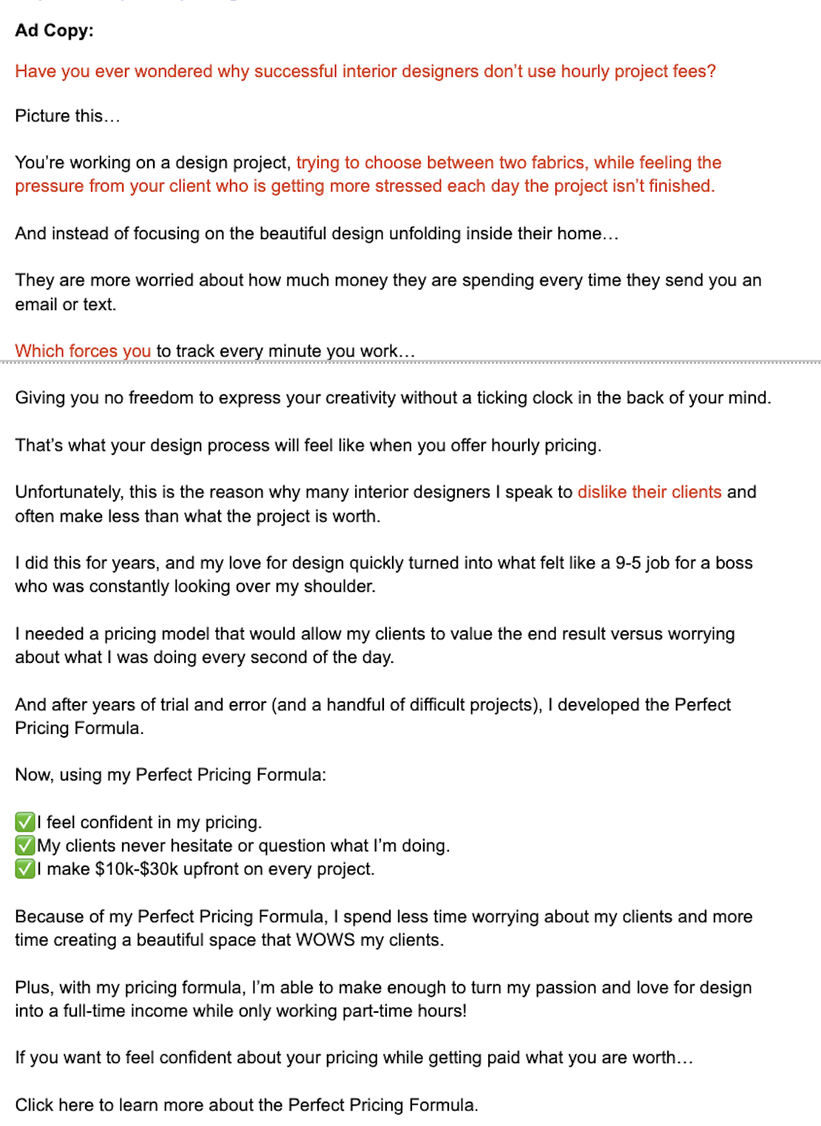

When you put them in a negative state, they go to your page in a negative state of mind.

Problem state of mind, so they look for problems, and ultimately to buy, they’re not going to buy a problem, but a solution

––––

Having too many CTAs makes it feel very forceful so you are not giving them space to reflect and decide

Asking them to buy non stop very frequently makes it very high pressure to buy and decide

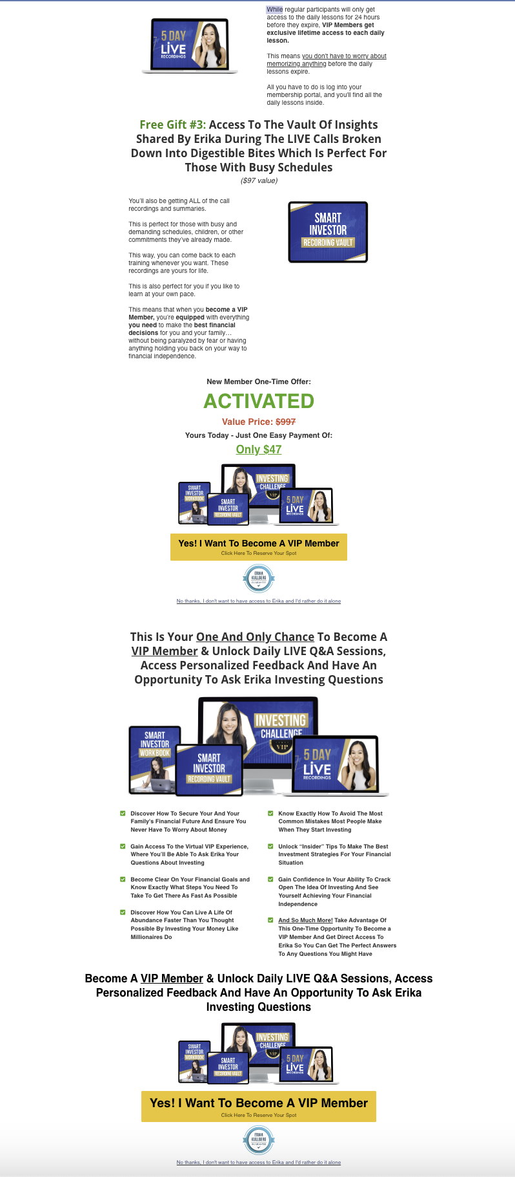

Give them space to buy on their own timeline, and offer them to buy later and they can save it.

Pressure in selling kills the sale.

—---

Help them “navigate”

CNN article:
Barnes had to adhere to strict rules imposed by French art heritage authorities during the renovation process.
Luckily, a restoration architect helped her to navigate procedures.

—---

Negative admittance is probably the #1 thing when it comes to selling to women.

If a woman tells you what she wants, then by default she’s admitting she doesn’t have it and also that you don’t care about her because she’s telling you what she wants.

If she has to do it, it’s not real. This is why women will get mad at you for not knowing what they want.

They’re not getting mad at you for not knowing what they want but rather you’re putting them in a position of negative admittance.

Oftentimes when you ask a woman what they want, they’ll oftentimes ask a question back.

Instead of asking them what they want…give them 3 choices.

Which choice do you want?

“There are 3 ways to get the outcome in __________, the 1st way will _______ the 2nd way will _______ and the 3rd way will ______, they all work, you just have to pick which one you want.

They pick what they want and don’t have to admit anything bad.

And you can always change your mind and pick the other path, it all works.

If you only have ONE way, it creates a very NARROW path.

This removes the pressure of performance.

—---

Never use the word YOU with women as that is an accusatory word

“Don’t say there is something about you”

Say something you need to know, something no one had the courage to ever tell you

Something that’s going to ________

That something is that you are ______, ____, ____

And that’s why deep down you can recognize that you have limitless potential that will allow you to have the life you always dreamed of having.

“You are” = identity

When you use the word YOU ARE with women, you are attacking who she is, if negative, and also you are saying…this is how EVERYONE SEES you.

Vs

“You have” = possession

You have a quality that allows you to vs YOU ARE

Be careful about making ASSUMPTIONS with the word YOU

—---
People tend to criticize themselves, because it’s easier to criticize themselves than others.
Women will criticize themselves.
If a woman is overweight, she thinks she’s really overweight.
You can’t go and say “stop criticizing yourself”
Don’t be so hard on yourself, because you don’t realize ____________
When you compliment them, it empowers them to move fwd.
How do you compliment them that’s beneficial to them and you?
You find something they have that is a GREAT that can allow them to get the outcome with your system/formula/product and this is the biggest reason as to why it’s in their benefit to move forward.
“You’ve always been a great writer, and that’s why i KNow that you’ll be phenomenal at copywriting”
Attach a positive value to something negative they see and can transform it.
This removes limitations and creates empathy.
When you look at limitations, once again you do the same process.
—---

To move fwd, women need to give themselves permission, so your job in sales copy is to help them give themselves permission, and justify it.

The way they give themselves permission is by others giving them permission.

Whatever they do that benefits themselves, will also benefit everyone they know and care about.

So they’re doing it for OTHERS, which means they’re doing it for themselves so they can get more SOCIAL value from others.

“Lose weight for your grandkids or kids”

“Make money for your family”

Anyone but themselves.

A lot of times when you’re selling to women, you need to help them give themselves permission to do something, and that is to be accepted by themselves.

They have to accept that they are GOOD enough to do this.

If they do not accept that they’re good enough to do this, they will DELAY the sale until they are GOOD enough.

So you can say “How about you give yourself a late xmas gift in 2024 that you know you deserve”.

And we’ll show you how to ____________

You have to get them to reward themselves, and how do you get someone to reward themselves? Well they have to earn the reward.

So you justify it by telling them how they’ve earned the reward.

—---

When selling to women, they need to connect to people not things.

They’re a lot more interpersonal

They need to connect to a PERSON, not a THING a system or something.

A person or people or a GROUP as the PRIMARY

Women care more about people

So people images = better = get more response than things.

—---

Women are solipsistic so this is why they only trust their feelings and always probe for truth.

Don’t try to change their feelings, redirect them.

I know you don’t like the keto diet, but did you know that X celebrity used keto diet to lose 20 pounds, but she did something different…

—---

Women absorb beliefs.

Women tend to be more social and more agreeable, which means they absorb beliefs easier and faster.

So you have to look at where they’re absorbing beliefs.

From this you can see where they absorb the beliefs and you can determine the entire value set of the ecosystem.

—

Women juggle a lot, social, business, relationships

Helping them juggle all that is key.

How can I juggle your things along with everything I’ve got?

Help them balance it.

If they’re really busy, take that 30 minute video, and make it a 5 minute video.

—

Selling to Women 3.0 PART 2 To be continued…

